Hautapu Traffic Lights for Positive Behaviour

To promote positive behaviour in classrooms we would like to initiate a school wide classroom behaviour management system.

There are four parts to the traffic lights system:

Green light- You are working well and showing a positive attitude towards learning.

Orange light- Stop and Think! You are on a warning.
- If you make a good choice and show the right attitude you will go back to green light.
- If you don’t change your attitude you will be on red light.

Red light- You are consistently not showing the right attitude towards learning. You will be sent to Mr Clark, Mrs Patel- Harman or Mrs Bennett to discuss your attitude and actions.

Gold light- You are consistently showing the right attitude towards learning and showing yourself to be a Hautapu Hero! Go and see Mr Clark to get a Principal’s sticker/stamp. 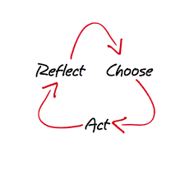
If a child doesn’t know how to read, we teach.
If a child doesn’t know how to swim, we teach.
If a child doesn’t know how to multiply, we teach.
If a child doesn’t know how to drive, we teach. If a child doesn’t know how to behave, we … teach……

Invariably we all make mistakes and children will make more mistakes than adults and learn from them. Our role as the teacher or facilitator is to help them to reflect on these and their actions and to help them to choose a different way to act next time. The key part of this is having a restorative conversation where we don’t judge the child’s actions, but instead inquire into those actions so they can Make the Right Choice the next time.

